Department of Computing

CS-344: Web Engineering
Class: BESE-9AB

Lab 06: XML and DTD

Date: Nov 19, 2020

Instructor: Dr. Qaiser Riaz

Lab 06: XML and DTD

Introduction:
XML is a well-known model for data exchange and data representation. During lectures, students have learned basic concepts of XML syntax, building blocks of an XML document, document type definition etc. This lab will be focused on creating DTD and XML documents.

Lab Objectives:
The objective of this lab is to help students in creating XML documents and validating XML documents by defining document type definition. Students will use the theoretical concepts they have learned in the lectures to create XML documents.

Tools:
Notepad, browser.

Helping Material:
Lecture slides.
W3Schools: https://www.w3schools.com/xml/default.asp, https://www.w3schools.com/xml/xml_dtd.asp

Ahmed Hassan Ismail – BESE-9B – 237897

Lab Task

Task 1
Consider the following student database.
Students Information Table:
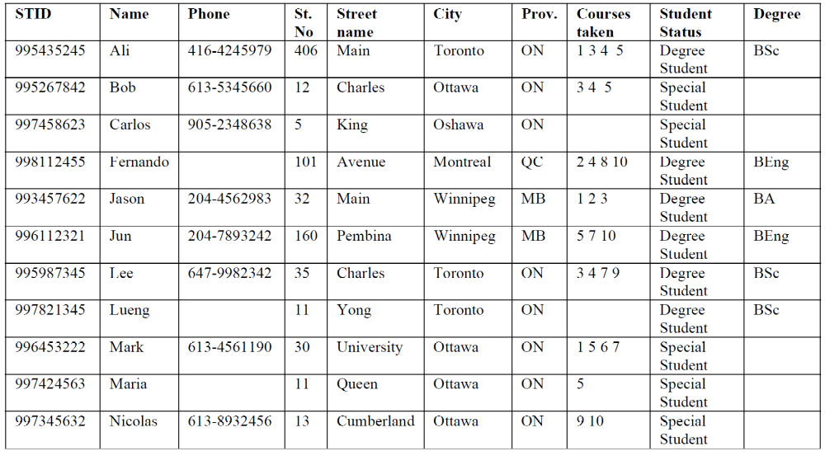
Course Information Table:
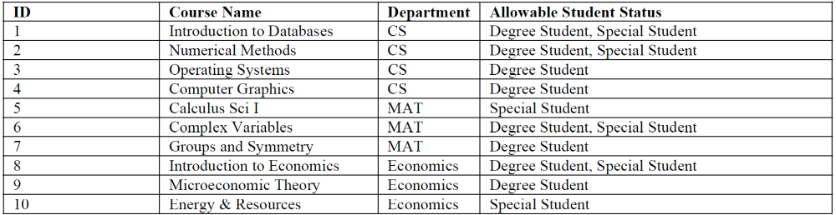

Question 1:
Define a DTD, students.dtd, for documents that list all courses offered, and then the courses taken by each student. The DTD should allow each registered student to take 0 or more courses. Phone numbers are optional. Also, only degree students have a degree attribute. A course may be taken by students whose status is degree, special or both. A student may be taking a course for which he/she can’t get credit (e.g., a special student taking a course for which only degree students get credit).

Question 2:
Provide an XML document, students.xml, which captures the information given in the tables above and is consistent with students.dtd.

Question 3:
Define a DTD that validates following XML document:
<?xml version="1.0" encoding="UTF‐8"?>
<student>
<firstName>Luca</firstName>
<lastName>Rossi</lastName>
<id>281283</id>
<plan>
<courses year="3">
<course>
<name> Programmazione Orientata agli Oggetti </name>
<shortName>POO</shortName>
<record>
<grade>30</grade>
<date>13/06/11</date>
</record>
</course>
<course>
<name>Analisi e progettazione del software</name>
<shortName>APS</shortName>
</course>
</courses>
</plan>
</student>

Question 4:
Define a DTD that validates following XML document:

<?xml version="1.0" encoding="UTF‐8"?>
<email>
<from> luca.rossi.917@gmail.com </from>
<to> atzeni@dia.uniroma3.it </to>
<content>
Dear <person> Paolo </person>,
here are some very hard exercises for the upcoming assignment of <course> web engineering </course>:
<exercises>
<exercise>
<topic> DTD </topic>
<description> From Instance to DTD </description>
</exercise>
<exercise>
<topic> XPath </topic>
<description> Find students with average grade better than 26 </description>
</exercise>
</exercises>
Best Regards,
<person> Luca </person>
</content>
</email>

Solution
Question 1:
<?xml version="1.0" encoding="UTF-8"?>
<!DOCTYPE Report [
<!ELEMENT Report (Students,Courses)>
<!ELEMENT Students (DegreeStudents,SpecialStudents)>
<!ELEMENT Courses (Course+)>
<!ELEMENT DegreeStudents (Student+)>
<!ELEMENT SpecialStudents (Student+)>
<!ELEMENT Student (Address,(Phone?),(CourseTaken*))>
<!ELEMENT Address EMPTY>
<!ELEMENT CourseTaken EMPTY>
<!ELEMENT Phone (#PCDATA)>
<!ELEMENT Course (Acceptance+)>
<!ELEMENT Acceptance (#PCDATA)>

<!ATTLIST CourseTaken CourseID IDREF #REQUIRED>
<!ATTLIST Address StNo CDATA #REQUIRED>
<!ATTLIST Address StName CDATA #REQUIRED>
<!ATTLIST Address City CDATA #REQUIRED>
<!ATTLIST Address Prov CDATA #REQUIRED>
<!ATTLIST Student STID CDATA #REQUIRED>
<!ATTLIST Student Name CDATA #REQUIRED>
<!ATTLIST Student Degree CDATA #IMPLIED>
<!ATTLIST Student Status CDATA #REQUIRED>
<!ATTLIST Course CourseID ID #REQUIRED>
<!ATTLIST Course Name CDATA #REQUIRED>
<!ATTLIST Course Department CDATA #REQUIRED>
]>

Question 2:
<?xml version="1.0"?><!DOCTYPE Report SYSTEM "students.dtd">
<Report>
<Students>
<DegreeStudents>
<Student STID="995435245" Name="Ali" Degree="BSc" Status="Degree Student">
<Address StNo="406" StName="Main" City="Toronto" Prov="ON"/>
<Phone>416-4245979</Phone>
<CourseTaken CourseID="c1" />
<CourseTaken CourseID="c3" />
<CourseTaken CourseID="c4" />
<CourseTaken CourseID="c5" />
</Student>
<Student STID="998112455" Name="Fernando" Degree="BEng" Status="Degree Student">
<Address StNo="101" StName="Avenue" City="Montreal" Prov="QC"/>
<CourseTaken CourseID="c2" />
<CourseTaken CourseID="c4" />
<CourseTaken CourseID="c8" />
<CourseTaken CourseID="c10" />
</Student>
<Student STID="993457622" Name="Jason" Degree="BA" Status="Degree Student">
<Address StNo="32" StName="Main" City="Winnipeg" Prov="MB"/>
<Phone>204-4562983</Phone>
<CourseTaken CourseID="c1" />
<CourseTaken CourseID="c2" />
<CourseTaken CourseID="c3" />
</Student>
<Student STID="996112321" Name="Jun" Degree="BEng" Status="Degree Student">
<Address StNo="160" StName="Pembina" City="Winnipeg" Prov="MB"/>
<Phone>204-7893242</Phone>
<CourseTaken CourseID="c5" />
<CourseTaken CourseID="c7" />
<CourseTaken CourseID="c10" />
</Student>
<Student STID="995987345" Name="Lee" Degree="BSc" Status="Degree Student">
<Address StNo="35" StName="Charlse" City="Toronto" Prov="ON"/>
<Phone>647-9982342</Phone>
<CourseTaken CourseID="c3" />
<CourseTaken CourseID="c4" />
<CourseTaken CourseID="c7" />
</Student>
<Student STID="997821345" Name="Leung" Degree="BSc" Status="Degree Student">
<Address StNo="11" StName="Yong" City="Toronto" Prov="ON"/>
</Student>
</DegreeStudents>
<SpecialStudents>
<Student STID="995267842" Name="Bob" Status="Special Student">
<Address StNo="12" StName="Charles" City="Ottawa" Prov="ON"/>
<Phone>613-5345660</Phone>
<CourseTaken CourseID="c3" />
<CourseTaken CourseID="c4" />
<CourseTaken CourseID="c5" />
</Student>
<Student STID="997458623" Name="Carlos" Status="Special Student">
<Address StNo="5" StName="King" City="Oshawa" Prov="ON"/>
<Phone>905-2348638</Phone>
</Student>
<Student STID="996453222" Name="Mark" Status="Special Student">
<Address StNo="30" StName="University" City="Ottawa" Prov="ON"/>
<Phone>613-4561190</Phone>
<CourseTaken CourseID="c1" />
<CourseTaken CourseID="c5" />
<CourseTaken CourseID="c6" />
<CourseTaken CourseID="c7" />
</Student>
<Student STID="997424563" Name="Maria" Status="Special Student">
<Address StNo="11" StName="Queen" City="Ottawa" Prov="ON"/>
<CourseTaken CourseID="c5" />
</Student>
<Student STID="997345632" Name="Nicolas" Status="Special Student">
<Address StNo="13" StName="Cumberland" City="Ottawa" Prov="ON"/>
<Phone>613-8932456</Phone>
<CourseTaken CourseID="c9" />
<CourseTaken CourseID="c10" />
</Student>
</SpecialStudents>
</Students>
<Courses>
<Course CourseID="c1" Name="Introduction to Databases" Department="CS">
<Acceptance>Degree Student</Acceptance>
<Acceptance>Special Student</Acceptance>
</Course>
<Course CourseID="c2" Name="Numerical Methods" Department="CS">
<Acceptance>Degree Student</Acceptance>
<Acceptance>Special Student</Acceptance>
</Course>
<Course CourseID="c3" Name="Operating Systems" Department="CS">
<Acceptance>Degree Student</Acceptance>
</Course>
<Course CourseID="c4" Name="Computer Graphics" Department="CS">
<Acceptance>Degree Student</Acceptance>
</Course>
<Course CourseID="c5" Name="Calculus Sci I" Department="MAT">
<Acceptance>Special Student</Acceptance>
</Course>
<Course CourseID="c6" Name="Complex Variables" Department="MAT">
<Acceptance>Degree Student</Acceptance>
<Acceptance>Special Student</Acceptance>
</Course>
<Course CourseID="c7" Name="Groups and Symmetry" Department="MAT">
<Acceptance>Degree Student</Acceptance>
</Course>
<Course CourseID="c8" Name="Introduction to Economics" Department="ECO">
<Acceptance>Degree Student</Acceptance>
<Acceptance>Special Student</Acceptance>
</Course>
<Course CourseID="c9" Name="Microeconomic Theory" Department="ECO">
<Acceptance>Degree Student</Acceptance>
</Course>
<Course CourseID="c10" Name="Energy and Resource" Department="ECO">
<Acceptance>Degree Student</Acceptance>
</Course>
</Courses>
</Report>

Question 3:
<?xml version="1.0" encoding="UTF-8"?>
<!DOCTYPE student [
<!ELEMENT student (firstName, lastName, id, plan)>
<!ELEMENT firstName (#PCDATA)>
<!ELEMENT lastName (#PCDATA)>
<!ELEMENT id (#PCDATA)>
<!ELEMENT plan (courses*)>
<!ELEMENT courses (course*)>

<!ATTLIST courses year CDATA #REQUIRED>

<!ELEMENT course (name, shortName, record?)>
<!ELEMENT record (grade, date)>
<!ELEMENT name (#PCDATA)>
<!ELEMENT shortName (#PCDATA)>
<!ELEMENT grade (#PCDATA)>
<!ELEMENT date (#PCDATA)>
]>

Question 4:
<?xml version="1.0" encoding="UTF-8"?>
<!DOCTYPE email [
<!ELEMENT email (from, to, content)>
<!ELEMENT from (#PCDATA)>
<!ELEMENT to (#PCDATA)>
<!ELEMENT content (#PCDATA|person|exercises|course)*>
<!ELEMENT exercises (exercise*)>
<!ELEMENT exercise (topic, description)>
<!ELEMENT topic (#PCDATA)>
<!ELEMENT description (#PCDATA)>
<!ELEMENT person (#PCDATA)>
<!ELEMENT course (#PCDATA)>
]>

Deliverables
Compile a single word document by filling in the solution part and submit this Word file on LMS. You must include your name, ID, and class on first page. The lab grading policy is as follows: The lab is graded between 0 to 10 marks. For some of the labs, students have to present their solutions in a viva session. In case of any problems with submissions on LMS, you should contact your lab engineer Mr. Aftab Hussain by email at aftab.hussain1@seecs.edu.pk.

